Parabolic Patterns

Stage:4 and 5 Challenge Level:

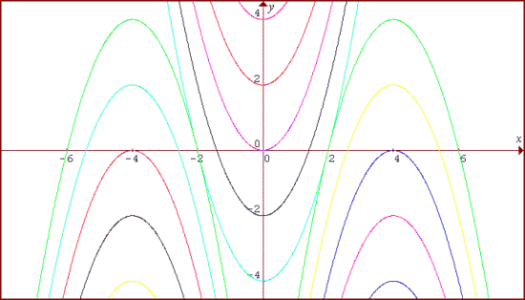
The illustration shows the graphs of fifteen functions. Two of them have equations
y = x ²
y = - (x - 4) ²
Use a graphic calculator or a graph drawing computer program to sketch these two graphs and then locate them in this illustration. Use the clues given in this information to help you to find the equations of all the other graphs and to draw the pattern of the 15 graphs for yourself. For your solution send in the equations you have found with an explanation of how you did it.

